Gradient Descent Intuition
In this video we explored the scenario where we used one parameter θ1​ and plotted its cost function to implement a gradient descent. Our formula for a single parameter was :
Repeat until convergence:
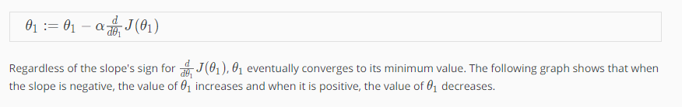
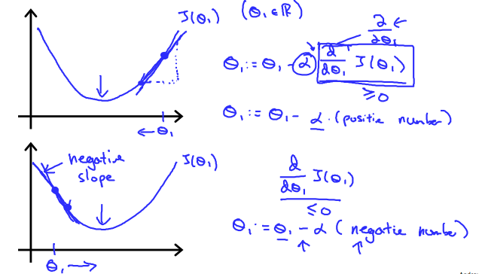
On a side note, we should adjust our parameter α to ensure that the gradient descent algorithm converges in a reasonable time. Failure to converge or too much time to obtain the minimum value imply that our step size is wrong.
